Notes: Moisture, Precipitation, Clouds

I. Water in the Atmosphere
- Water exists in ____________________________ different forms.
- What are they?
  - ______________________ Examples: _____________________________________
  - ______________________ Examples: ______________________________________
  - _______________________ Examples: ____________________________________
- When it comes to understanding ____________________________________________________, ___________________________________ is the most important ____________________in the atmosphere.
- Even though water vapor is important, it only makes up from _________________________________ of the atmospheric gases.
- Water vapor is the ___________________________that you_______________________ in the____________________!
- Air that has _________________________________________________________________________ is said to be _________________________________________
- __________________________________, saturated air contains ___________________________ water vapor than cold air
- ___________________________________ is the temperature to which air is cooled to reach saturation.
  - The point at which condensation can occur
- When have you noticed the humidity more, in the summer or in the winter?

- That’s because ______________________________ can hold _________________________________!
- Relative Humidity
  - ____________________________________________________ is the ratio of air’s water-vapor content to its capacity to hold water vapor at that same temperature.
  - Relative humidity indicates _________________________ the air is to saturation, __________________ the actual quantity of water vapor in the air.
  - Relative Humidity _______________________________________________________________
  - _____________________ air __________________________________ its relative humidity.
  - _____________________ air __________________________________ its relative humidity.
  - Why does lowering the air temperature cause Relative humidity to increase?
    - Because colder air ________________________________________________________
  - Why does increasing air temperature cause relative humidity to decrease?
    - Because warm air _____________________________________________ and it will take more water vapor for it to become __________________________________
II. Lifting Air
- When air is compressed the air molecules _____________________________________________ and the temperature rises.
- ____________________________________________________ causes changes in temperature even though heat isn’t added or subtracted.
- When air is allowed to expand, _________________________________________
- When air is compressed, _______________________________________________
- Four mechanisms which cause air to lift:
  - Orographic Lifting
    - Orographic lifting occurs when mountains act as barriers to the flow of air, forcing the air to ascend.
  - Frontal Wedging
    - A front is the boundary between two adjoining air masses having contrasting characteristics.
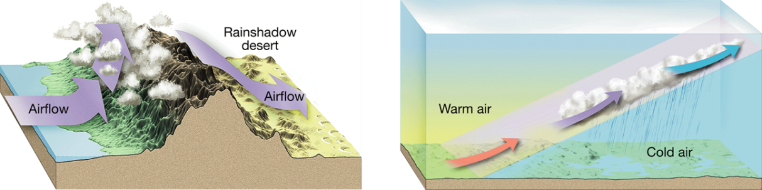
  - Convergence
    - Convergence occurs when two air masses converge. The air flows together and rises.
  - Localized Convective Lifting
    - Localized convective lifting occurs where unequal heating on earth’s surface causes pockets of air to rise.
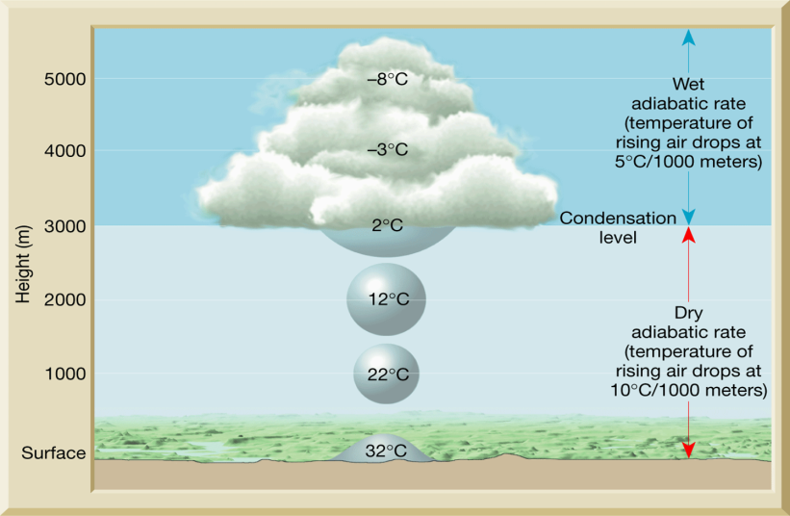
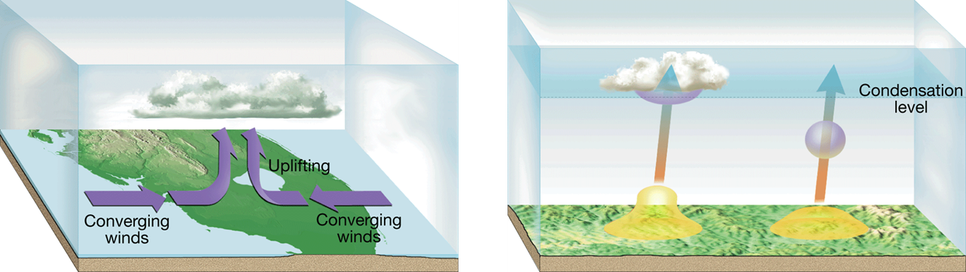

*When air expands to form clouds, the water vapor is transformed to clouds by condensation.

*Generally, there must be a ____________________ for water vapor to ____________________ on.

*__________________________________________are tiny bits of matter that serve as surfaces on which water vapor condenses when condensation occurs
*Examples of condensation nuclei include _______________________________________________

