Soil Notes
I. Soil Composition
- Soil is a mixture of ____________________________________________________________________________________
____________________________________________________________________________________
- Organisms don’t just live in the _____________________rock but they ______________________________________
- Kinds of soil particles give soil it’s ____________________________
- The texture affects its capacity to retain ____________________________________________________________________________________
Particle | Size | Feels
Gravel
Sand
Silt
Clay
Loam: ______________________________________________________________________________________________________________________________________________________________________________
Ratio: _______________________________________
- Particles separate with _________________________ at bottom
II. Soil Triangles
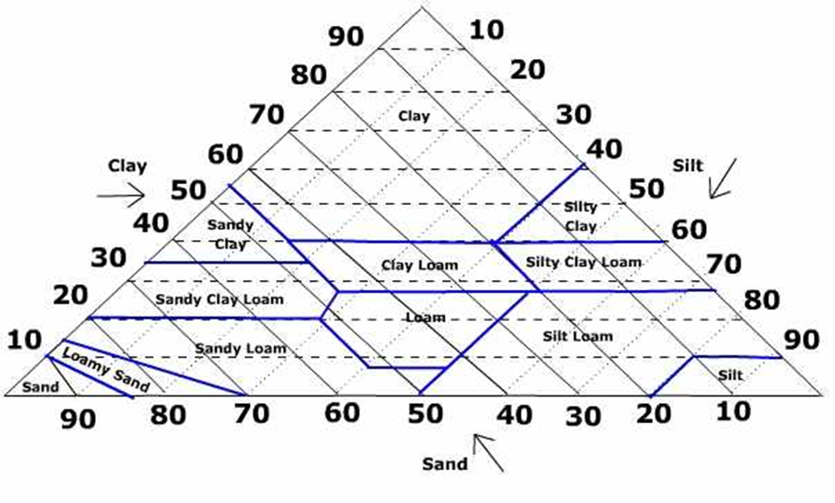
1. 15% clay, 70% silt, 15 % sand ________
2. 20% clay, 30% silt, 50% sand _________
3. 80% clay, 10% silt, 10% sand _________

III. Judging Soil Quality
- _________________________________________________________________________________
- _________________________________________________________________________________
- _________________________________________________________________________________
- _________________________________________________________________________________
- _________________________________________________________________________________
Best soil type for plants:___________________________________________________
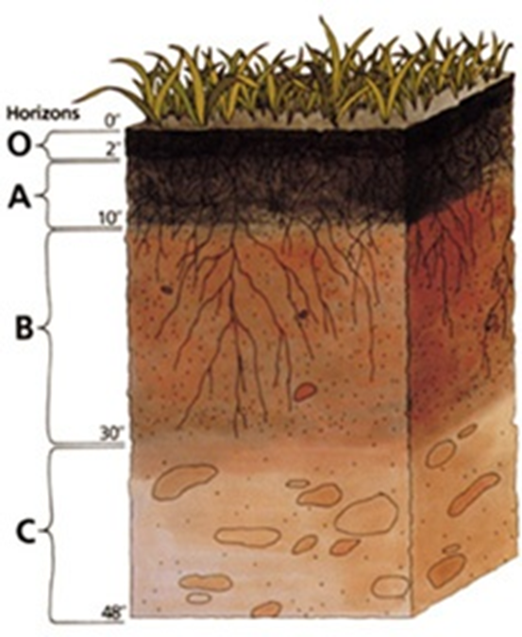
IV. Soil Profile:____________________________________________________________________
- Each layer is called _____________________________
- 3 horizons labeled A, B, C
- (*O horizon is leaf litter)
- _______________________ is the top layer of soil.
  - ____________________ containing sediments, decayed leaves, the roots of plants, insects and worms.
  - __________________________________________ since it was weathered rock
  - Has _________________________________________ than other horizons
* Humus ______________________________________
________________________________________________
________________________________________________
- _______________ Horizon is the 2nd layer
  - It is _________________________________________, less evolved
  - Has _______________________________________, some plant roots reach to this layer.
  - Contains ___________________________________________________________________ from horizon A in a process called leaching.
* Leaching ___________________________________________________________________
______________________________________________________________________________

- _________________ Horizon is the bottom layer
  - Some material is leached from horizon B
  - _____________________________________________
  - Partly weathered rock
  - What is underneath this layer?_____________________________________________________
V. Are all soil profiles the same?
- NO! The thickness and the soil composition depend on ______________________________________
___________________________________________________________________________________
- Other factors
  - Slope of land, amount of humus, _________________________________________________
  - Ex. Soil in cold, dry climates has thin horizons b/c weathering is slower.
* *It can take hundreds of years for 1 cm of soil to form.
Soil Loss Example: “Dust Bowl”
- Overgrazing, poor farming practices and drought caused tons of topsoil to be lost.
- Desertification….__________________________________________________________________________
- 3 human activities:
  - __________________________________________________________________________________
__________________________________________________________________________________

