Origin/Ocean Intro Notes
Aquatic Biomes: ______________________________________________________________________
Determined by __________ factors
- Amount of _____________________
- Amount of _____________________
- Amount of _____________________
Freshwater Biome: ______________________________________________________________________________
Marine (Oceans and Seas): ____________________________________________________
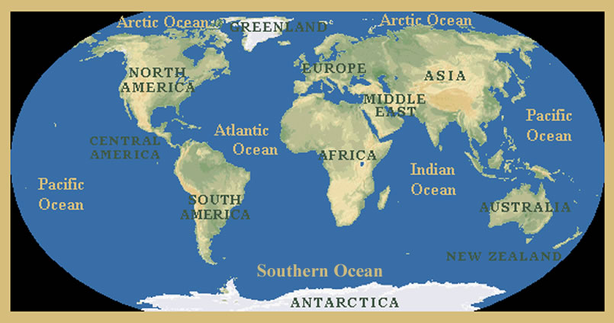
- _________________________________ is contained in the ocean. ____________________________________________________
Seas: Smaller than oceans and are mostly ____________________________________
  - Ex. Mediterranean Sea

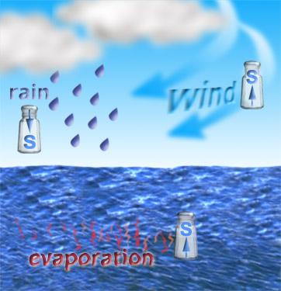
Estuary: Where the _________________________ meets the ____________________ of the ocean. Act as filters. The ____________ North Carolina estuary is ____________________. Water drains into this system from eastern North Carolina and southeastern Virginia, from the Chowan, Roanoke, Pasquotank, Pamlico, and Neuse Rivers, from marshes, swamps, forests, and grasslands.
Where did the ocean come from?______________________
_________________________________________________________
_________________________________________________________
_________________________________________________________
Basin:__________________________________________
Where did elements in ocean water come from?
1._____________________________________________________
2._____________________________________________________
Properties of Ocean Water: SALINITY
The_____________ most abundant dissolved elements are ___________ and ____________________ together forms the salt ________________
- ____________ of salt in seawater is made of dissolved Na+ and Cl- NaCl (10% is other salts like __________________________)
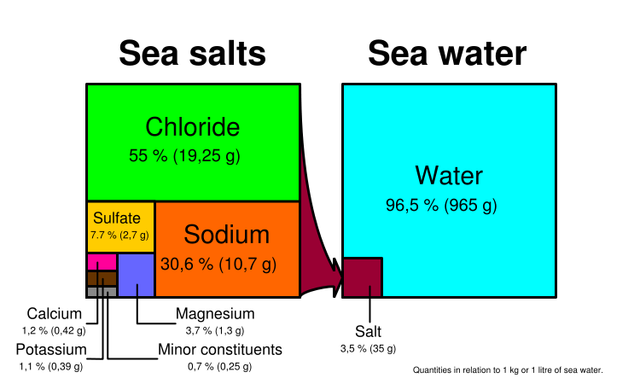
So how salty is the ocean? Consider the following – For every 1000L of water, ______________________ (3.5%)
Salinity

- is the measure __________________________ in seawater.
- The salinity of the ocean has stayed the same for millions of years _________________________
Properties of Ocean Water: Temperature
The ________________ is the source of ______________________for ocean water.
- Temperature determines: ______________________________________________________
100-400m __________________________zone
  - Fairly constant temp except of seasonal changes.
Thermocline – ______________________________________
  - Warm surface water does NOT mix easily with colder deep water. WHY? _____________________________
- From thermocline to 4000m+ is the __________________
- Extremely cold water _______________________

What is __________________________________?
Climate Research, Hurricane Forecasting, El Niño & La Niña Forecasting, Ship Routing, Offshore Industries, Fisheries Management, Marine Mammal Research, Coral Reef Research

