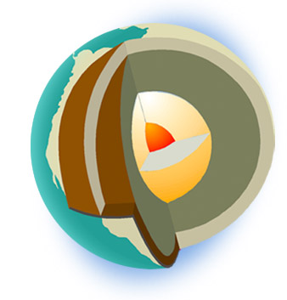
Name:
Date: Per.

Online Investigation of Earth’s Crust
http://www.learner.org/interactives/dynamicearth/index.html

Start with Earth’s structure:
- Draw a diagram (on a separate sheet of paper) to show the layers of the earth or label the one above.
- As you roll your mouse over the layers, write down a brief description for each. Note weather each is solid, liquid or some in between, composition and any unique features.
  - Crust:
  - Lithosphere:
  - Asthenosphere:
  - Mantle:
  - Outer Core:
  - Inner Core:
II. Plate Tectonics
- When you are done, go to the next chapter (plate tectonics), follow the prompts and answer the questions below.
  - How has the crust of the Earth changed over time?

  - Click the “How do we know this?” button.
    - Who was Alfred Wegener and what observations did he make that led to the theory of Continental Drift:
  - What did he call the original land mass?
  - Summarize the basics of the “Plate Tectonic Theory”:
  - Click “Continents Over Time” and see if you can trace how the earth’s continents have shifted over time.
III. Plate Boundaries
- Draw a diagram, describe and give 1 example of each of the boundaries below:
 | Convergent | Divergent | Transform
Diagram

Description

Example

- Scroll down to the plate boundary map and use the key to find the different types of boundaries.
- Which plate do we live on?
- If we travelled to Europe, which plate would we be on?
- If we travelled to Hawaii, which plate would we be on?

IV. Click on the tab “Slip, Slide, & Collide” from across the top. After you read about what happens at plate boundaries, scroll to the bottom and click on “See what happens at different plate boundaries”
- Convergent Boundaries – colliding plates
- Ocean crust tends to be and than continental crust.
- A subduction zone occurs when:
- A trench forms when:
- Observe and summarize how the volcano is formed:
- Describe how an island arc is formed:
- What is a tsunami and why are they common at subduction zones?
- What happens when two continental plates converge?
- Give an example of a mountain range formed in this way.
- Which two plates were involved in the formation of this mountain range?
- Divergent Boundaries – Spreading Plates
- At a divergent boundary plates are moving
- Summarize the steps involved in Seafloor Spreading:
- What is a mid ocean ridge and how is it formed?
- What is a rift and how is it different from a mid ocean ridge?
- Transform Boundaries – Grinding Plates
- Fault:
- Why are earthquakes common along faults or at transform boundaries?
- A transform boundary and its fault are often called a fault.
- Plate Interactions Challenge:
- Complete the interactive challenge with 4 case studies and a word jumble. Score:
- Test Skills
- Complete the Test Skills section when you have finished the assignment.
Score:

