Mineral Electronics Instructions
Objective: To design an electronic of your choice (iPhone, xbox One, etc.) and show how minerals are used in our everyday lives.
Helpful website: https://www.mineralseducationcoalition.org
Directions:
1.) Put your name, date, period at the top right corner of your paper.
2.) Design an electronic of your choice with an outside and an internal view.
3.) Choose 5 appropriate parts that are made from minerals for each electronic.
4.) Draw and label these parts with the name of the item and the minerals they are made from.
5.) List the country of origin for each mineral.
6.) Coloring your electronic is mandatory.

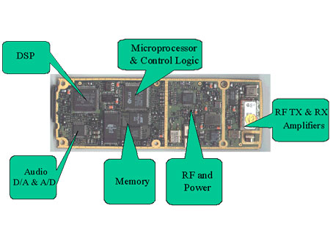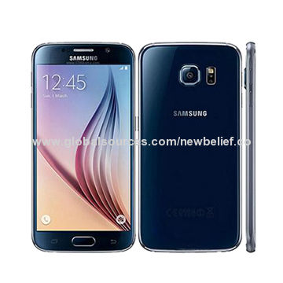

Mineral Electronics Instructions
Objective: To design an electronic of your choice (iPhone, xbox One, etc.) and show how minerals are used in our everyday lives.
Helpful website: https://www.mineralseducationcoalition.org
Directions:
1.) Put your name, date, period at the top right corner of your paper.
2.) Design an electronic of your choice with an outside and an internal view.
3.) Choose 5 appropriate parts that are made from minerals for each electronic.
4.) Draw and label these parts with the name of the item and the minerals they are made from.
5.) List the country of origin for each mineral.
6.) Coloring your electronic is mandatory.

