Erosion and Deposition
4
- ________________ (FORCES) of erosion: __________________________, ____________________, __________________________, __________________________.
- All have 1 thing in common: they carry sediments ______________ when they have enough _____________________________________.
______________________________ - dropping of sediments
- All agents of erosion _________________ their sediments when their energy of motion ____________.
Gravity
Can cause materials to move ___________________________________.*Actually the ________________________________________
Creep  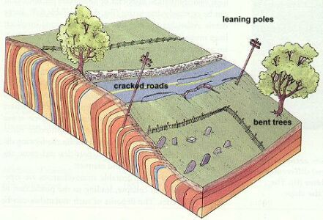 | Happens when sediments slowly creep downhill due to ______________________.  Results in -
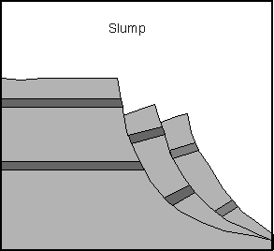  Slump | Takes place on steep slopes as loose materials ____________________________________.  - Doesn’t travel very fast or far.
Earthflow/Mudflow | - Dry areas have ____________________ sediments (due to weathering).  - When heavy rains occur, ____________ ________________________________  (think chocolate pudding consistency).  Gravity causes it to __________________
Landslide/rockslide | - ___________________ break loose from steep slopes and fall quickly to the bottom.  - Occur in ____________________ areas.  Can happens after ______________________ _____________________________________
All Mass Movements –
- Are more likely to happen where there is a _______________________.
- Depend on _________________________________.
- Will occur __________________________________________ because water adds mass and makes the sediments slippery.
- Cause a ___________________________ of the slope so it becomes less steep.
Slowing down erosion when land is prone to erosion -
- People must always battle erosion problems – _____________________________________________.
- Reduced by planting ________________________________to help hold down ________________and absorb _______________________________
Slow gravity erosion -_________________ Wall - Can keep rocks and soil from _________________.
Also can be built along ___________________________________________________________ to reduce erosion caused by flooding, running water, or waves
Water erosion: ______________________________________ sediments than any other agent of erosion does.
- WHY? It usually has ____________________________________. Ex. Rill erosion and _______________
Possible solutions – Retaining walls, ______________________ (broad steplike cuts made into the side of a slope).
When water flows onto a terrace it ______________________, has less energy and cannot erode as much.
Wind erosion
- Erodes by ______________________________________. Ex. Desert pavement
_____________________: Most common wind deposit and constantly changes as wind erodes them.
- Slow down erosion of dunes by allowing sediments _____________________________________________ (ex. Christmas tree or rock).
- __________________________________________ help trap sand. Fences also keep people of dunes.
What about on tilled farmland?
- Windbreaks – ________________________________________________________________________

