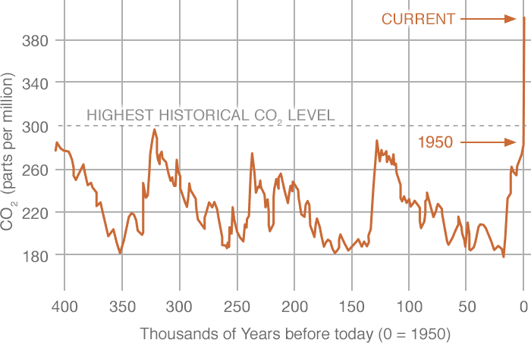
Source: NASA Reconstruction from Ice Cores, Courtesy of NOAA

