Name:
Period: Date:
Notes: Structure and composition of our atmosphere.

- Weather and Climate… what’s the difference?
  - Weather is always ________________ and refers to the state of the ________________at a given _______________________________
  - Climate is based on the observations of weather conditions over ________________and helps us describe a ____________
  - To understand weather and climate, we first need to understand what our atmosphere is made of

- The Composition of the Atmosphere
  - How old is the earth? _______
    - Over this period of time the composition of the atmosphere has _________ dramatically
  - “Air” is not a single gas, it is ___________ ___________________
    - The most abundant gas in the atmosphere is __________________________
    - The second most abundant is oxygen
      - Together make up _____% of clean, dry air
    - ___________________ is important for ___________________________ in the atmosphere
    - ____________________is the source of all ___________ and _______________and ____________________________ given off by Earth
  - Ozone: a form of _______________with three oxygen atoms bonded together instead of just two (that’s the O₂ we breathe)
    - Results from oxygen absorbing ____________ _____________________________________
    - The ozone layer is crucial for life on Earth because it ______________ potentially harmful ________________
    - The ozone layer ________________________ _____________________________________

- We just finished talking about the oceans, which contain water.
  - Liquids are one type of fluid
  - _____________________________________
  - Most of the properties of our atmosphere that __________________________________________________ as we know it, come from the fluid nature of the atmosphere

- The Structure of the Atmosphere
  - The atmosphere ______________ very quickly as you travel ______________ from Earth’s surface
  - The atmosphere is divided _______________ into ___layers based on _______________
  - Layers of the atmosphere
    - The lowest = _________________________
      - Temperature decreases as altitude increases
      - Most important _____________phenomena occur here
    - 2nd = ________________________
    - 3rd = ________________________
    - Top = _______________________

END OF PART I
- The Earth and Sun interactions
  - Nearly all of the energy for changing weather and climate comes from the ________
  - The Sun is the source of all energy in the atmosphere.
  - This energy is transferred to Earth and throughout the atmosphere through conduction, convection & radiation.
    - _ is the transfer of energy that occurs when molecules collide.
      - Through conduction, energy is transferred from the particles of air near Earth’s _ to the particles of air in the _ layer of the atmosphere.
      - For conduction to occur, substances must be _ with one another.
      - Conduction affects only a _ atmospheric layer near Earth’s surface.
    - is the transfer of energy by the flow of a heated substance.
      - Pockets of air near Earth’s surface are heated, become _ than the surrounding air, and _ .
      - As the warm air rises, it _ and starts to _ .
      - When it _ below the temperature of the surrounding air, it increases in density and _
      - Convection currents are among the main mechanisms responsible for the vertical motions of air, which in turn cause different types of weather.
    - is the transfer of energy through space by visible light, ultraviolet radiation, and other forms of electromagnetic _ .
      - The Sun is shining on, and therefore _ , some portion of Earth’s surface at all times.
      - While Earth is _ solar radiation, it is also continuously _ energy back into space.

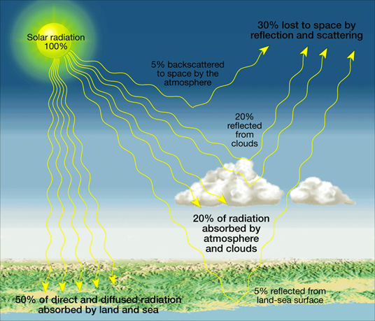
- How much of the Sun’s energy that reaches Earth’s atmosphere is reflected back into space? (add together the amount that is backscattered to space, the amount reflected from clouds, and the amount reflected by the land-sea surface)

2. How much of the Sun’s energy is absorbed by Earth’s atmosphere and clouds?

3. How much of the Sun’s energy is absorbed by the land and sea?
- If we did not have ___________to absorb solar radiation, Earth would not be a place where we could live
- This heating of the lower layer of the atmosphere from radiation absorbed by heat absorbing gases is called the _________________________________
- … so just like plants grow better in a greenhouse, all life on Earth is able to flourish because of the greenhouse effect
- The temperatures we experience are due to _______________________ of the atmosphere ________________ and _______________________________________________________.
- Land _____________________________________________________________ than water
- Land also reaches _______________________________________________________ than water
- The temperature of the land and water influences the temperature of __________________________________
- This explains why ____________________________ experience ______________________ temperature variations than cities near _________________________________

