Examining Porosity and Permeability
Part A: Color in the pore space between each of these soil samples with sorted particle sizes.
Answer: Circle your prediction about the porosity and permeability of each of the sorted soil samples below.
CLAY SILT SAND LOAM
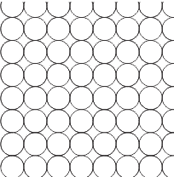
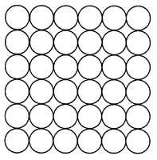
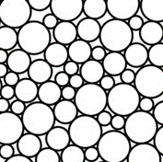

Porosity HIGH / MED / LOW HIGH / MED / LOW HIGH / MED / LOW HIGH / MED / LOW
Permeability HIGH / MED / LOW HIGH / MED / LOW HIGH / MED / LOW HIGH / MED / LOW

Part B: Color in the pore spaces between each of these soil samples with a mixture of particle sizes.
Answer: Which soil would let the water pass through more quickly? Explain your answer.

Answer: Which soil would hold the most water? Explain your answer.
1. 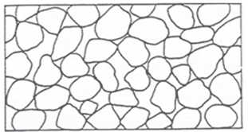 2.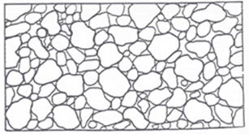
Part C: Trace the path of a drop of water from the surface down to the water table through the permeability maze.
Answer: Which illustration allows water to flow more freely?
1. 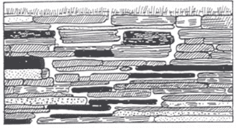 2. 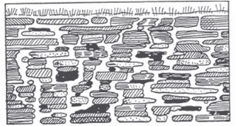
WATER TABLE

