Continental Drift – The story begins
As accurate maps were developed, people noticed the continents fit together like __________________.
- ___________________________ (1912) proposed that the continents were joined together in the past and broke apart about ____________________________. There was not enough evidence for this hypothesis at the time, so it was rejected by the scientific community. _________________________ continents have moved horizontally to their current location
The large landmass was called _____________(meaning all the Earth).
What evidence did Wegener have?
Evidence | Details
Fossil and Climate Clues | Fossils like _____________________________ were found on different continents.  Fossils of warm weather plants indicate ______________________________  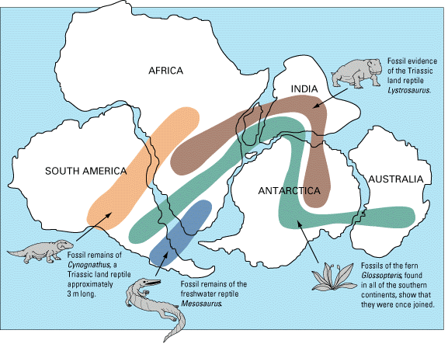
Rock Clues | 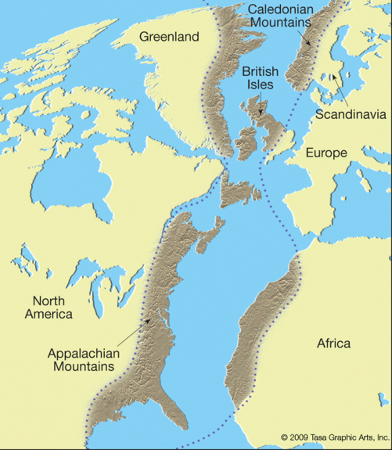  Similar rock structures were found on different continents.  Ex. _____________________________________________  _________________________________________________  _________________________________________________  _________________________________________________  _________________________________________________

More evidence - How was continental drift finally explained?
Marie Tharp-________________________________________________________
Harry Hess -_________________________________________________________
They suggested that ________________________________________ (underwater mountain chains) were formed when hot, less _______________ material in the mantle (2nd layer of the Earth) is ____________________ and carries the seafloor ways from the ridge. This is called ________________________ and ______________________________.
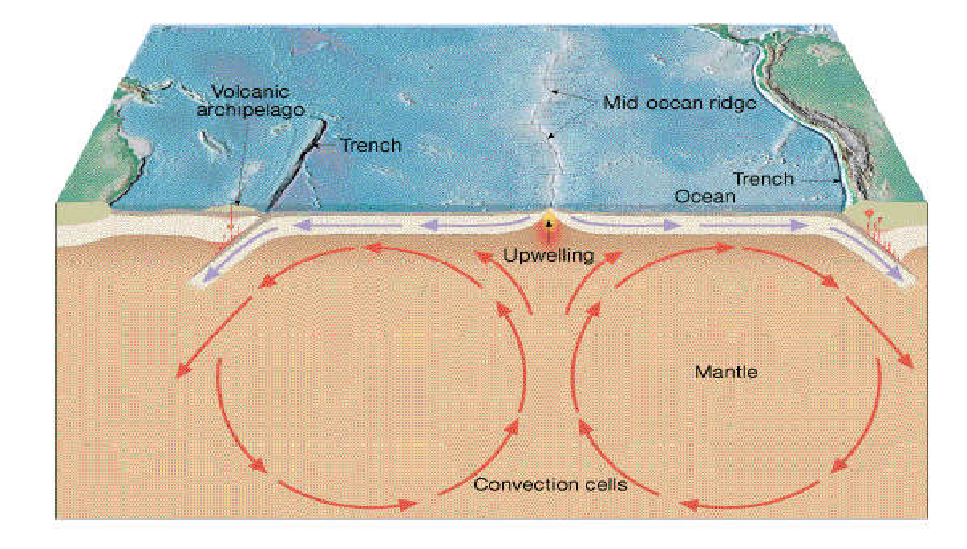
How did they test this idea?
Age Evidence | Rocks in the seafloor are much __________________ than on the continents and the youngest rocks are at the _____________________________________.
Magnetic clues called __________________________  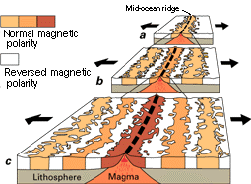 | The ____________________ core creates a ___________________ and periodically (around every 500,000 to 1,000,000 years) reverses polarity.  For example all rocks that form from cooling magma will be magnetized with north pole (magnetic north). When the magnetic field ________________, rocks would crystallize and have a magnetism that lines up with the South Pole (magnetic south).  Rocks in the ocean show many _____________________ proving that new rock was being formed at mid-ocean ridges.

