2.6.3b Heat Islands
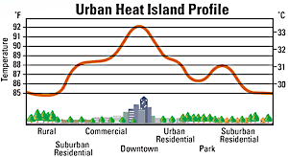
- What is an Urban Heat Island?
- The term "heat island" refers to air and surface that are than nearby areas.
- What factors can cause a Heat Island?

- Heat Islands
  - The principal reason for the nighttime is that buildings block surface heat from into the relatively cold night sky.
  - Tar, , brick and concrete absorb and release it as heat, rather than reflecting it (without heat) like soil does.
- Rural vs Urban
  - During the day in areas, the solar energy absorbed near the ground evaporates from the vegetation and soil. Thus, causes .
  - In , where there is less , the buildings, streets and sidewalks absorb the majority of solar energy input.
- What about the buildings and the people in them?
  - Remember, the way the heat island effect works, is that it the overall temperature of the city.
    - Like the effect: trapping heat on the surface
  - But in particular, it raises night time temperatures (not always day time) by the of heat, which makes an overall increase
  - Example: Night temperatures in Phoenix are degrees F warmer than before 1970
- Effects of Heat Islands
  - Can raise temperatures over 1 to more than 10 degrees F over that of surrounding areas.
  - Can increase peak demand
  - Air costs increase
  - Air increase
  - -related illness and increase

