2.6.2b Greenhouse Effect
- Climate Change
  - All life on Earth depends on climate conditions like and .
  - Our planet is getting —the 2000s were the warmest decade ever recorded. The term used to describe this increase in the average temperature of the Earth is .
  - Scientists are trying to determine if this is a of climate change or if it is caused by
- Greenhouse Effect
  - The is a natural warming of both Earth’s lower atmosphere and Earth’s surface from solar radiation being absorbed and emitted by the atmosphere.
  - The most widely accepted hypothesis is that global warming is at least partially due to human activities that add and other to the atmosphere.

    - Other greenhouse gasses include:

      - Carbon Dioxide (CO2)

Draw a diagram of the Greenhouse Effect:

What do you think?
- Global Warming
  - According to this hypothesis, the burning of combined with cutting and burning of worldwide is adding carbon dioxide to the atmosphere faster than it can be removed in the .
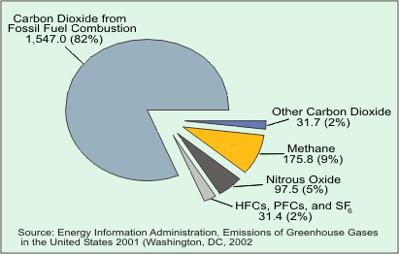
  - This causes heat from the sun to be trapped in the air instead of being bounced back into space, which makes the planet warmer.
- Why do we focus on CO2?
  - We emit more than any other greenhouse gas.
  - While other gasses may trap more like methane, they are harder to (“natural sources”)
  - Acid Rain
    - Forms when ____________________________ (remember from our NASA Satellite images) and __________________________________________are released into the air.
    - These mix in the clouds to form _____________________________, which can affect the acidity of __________________, harm wildlife, and __________________________________________________.

