Notes: Fronts and Weather

- Air Masses and Weather
  - Weather patterns result from the movement of large bodies of air called _____________________
  - Air masses are characterized by similar ________________________ and amounts of ___________________at certain altitudes.
  - When air masses move, the ________________ of the air mass _________________ and the________________ in the areas over which they move ____________________
  - Example of air mass/weather interaction:
    - A cold, dry air mass moves over warm, tropical waters
    - The air mass becomes _________________ and __________________
    - The weather over those waters becomes ______________ and _________________
You try….
- A warm, dry air mass moves over a cold, wet area
- The air mass becomes ________________ and _______________________
- The weather over that area becomes _____________________ and ____________________
- When air masses meet…..Fronts
  - When two air masses ___________, they form a _________________--the _____________________that separates the two
  - There are four different types of fronts
    - ___________________ fronts
    - ___________________ fronts
    - ___________________ fronts
    - ___________________ fronts
- Fronts
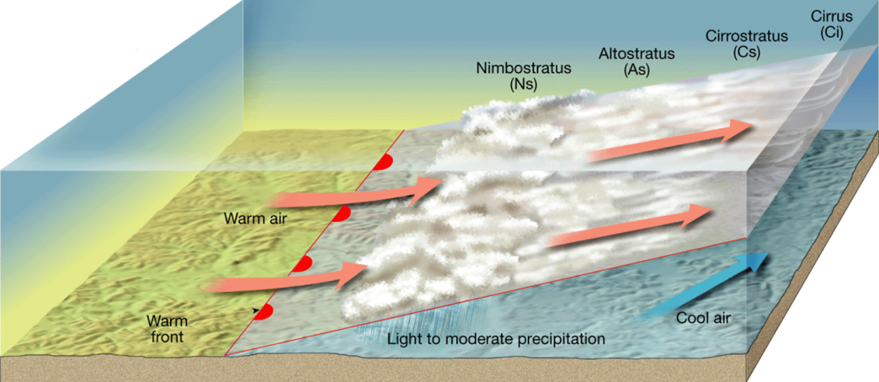
  - Warm fronts
    - Form when _____________ air moves into an area _________________ covered by ____________________
    - Shown on a weather map by a ___________ line with ______________________ pointing toward the _______________________.
    - As the _________________________ air rises, it cools
    - This produces clouds and frequent precipitation
      - Warm fronts move ____________, so the precipitation is _______________________ over a ____________________ for a ______________ period of time
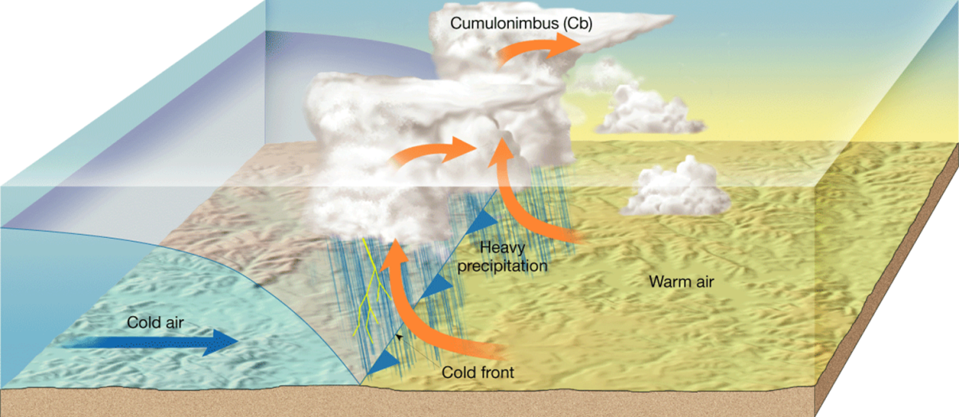
  - Cold Fronts
    - Form when __________, dense air moves into an area _________________ occupied by ____________________________.
    - Shown on a weather map by a ____________ line with __________________ pointing toward the __________________ air.
    - Draw a picture:
    - Move much ____________________ than warm fronts
    - Associated with _________________________ that is ______________________.

  - Stationary Fronts
    - Form when the flow of air is neither toward the cold air mass, nor toward the warm air mass
    - The front _________________________
    - Shown by ________________ on one side and _____________________________ on the other.
    - Draw a picture:

    - Gentle to moderate precipitation
  - Occluded Fronts
- Forms when a cold front _________________________ a warm front
- ______________________ weather patterns

