Name:
Period: Date:
2.3.2a Water Cycle, Surface Water, and Ground Water

The Water Cycle
Water is EVERYWHERE
About ___________ is in the oceans
About ___________ is in glaciers and ice sheets
About ___________ is freshwater in lakes, streams, groundwater, and the atmosphere
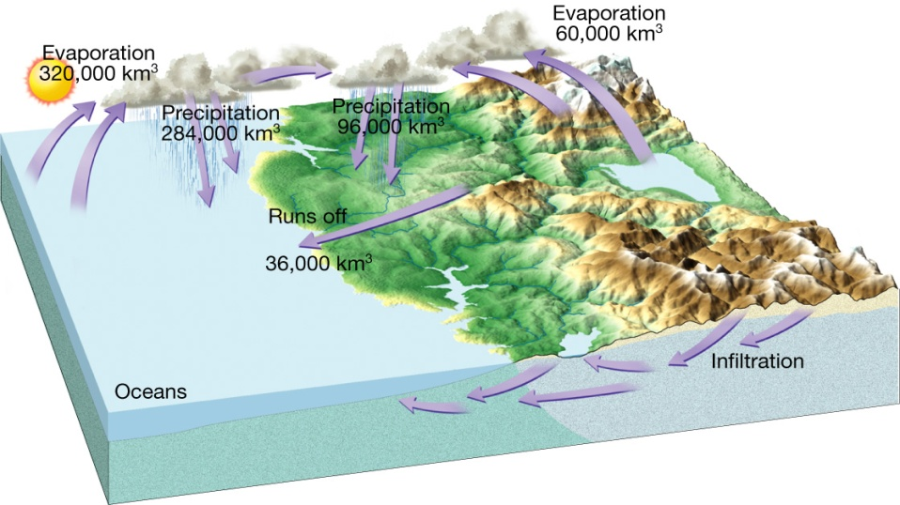
Water constantly moves among the ___________ , the ___________ , the ___________ ___________ , and the ___________ . This unending circulation of Earth’s water supply is the ___________ ___________

How much of our planet is freshwater?_____________________________________

Water Beneath the Surface
Distribution and Movement of Water Underground
Much of the water in soil seeps _________________________ until it reaches the ____________________
_____________________________.
The ______________________________________ is the area where water __________________________
________________________ spaces in sediment and rock.
• ___________________ is the water within this zone.
• ________________________________________ is the upper level of the saturation zone of groundwater.

Movement
• Groundwater moves by twisting and turning through ___________________________________________.
• The groundwater moves ________________________ when the pore spaces are _____________________.
Movement- depends on 2 factors
• ________________________
- The ____________________ of pore spaces
- Determines _______________________ groundwater can be __________________
• ________________________
- _____________________________________________ water through connected pore spaces
- _______________________ are permeable rock layers or sediments that transmit groundwater __________

Based on the figure: What is the difference between the zone of saturation and the zone of aeration?
______________________________________________________________________________________________________________________________________________________________________________________________________________________________________________________________________________
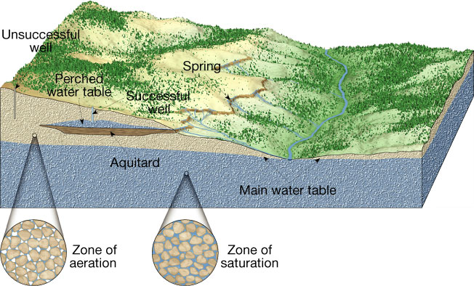

Why is the well labeled A a successful well whereas the well labeled B is unsuccessful?
A
B

________________________________________________________________________________________
Aquifers
- An aquifer is soil and/or rock through which water can easily .
- is stored in aquifers
- Types of Aquifers
  - aquifer
    - Has no barrier between its top layer and the of the ground
    - Water level rises and drops in response to infiltrating directly above
  - aquifer
    - Sandwiched between two largely layers (clay, shale, etc)
    - Recharges more slowly due to limited number of places through which rainfall can enter
Aquifers of NC
- Coastal Plains:
- Piedmont and Mountains:
END OF PART I
Remember: A drop of water can either infiltrate into the ground (groundwater) or runoff the surface into a river or stream
Groundwater and surface water have a relationship, regularly feeding each other. Most streams and rivers get about their volume from groundwater.
Floods
- During a flood, surplus water helps recharge groundwater.
- A flood occurs when the discharge of a stream becomes so that it exceeds the capacity of its channel and its banks.
- What are some things that cause flooding?

- There are several methods used to help prevent flooding:

Drainage Basins
- A drainage basin is the that contributes water to a stream.
- A is an imaginary line that separates the drainage basins of one stream from another.
- Drainage System
  - formed by streams, rivers, and lakes
  - Depends on
    - Topography of the land ( ____________ )
    - Hard or soft rocks
    - Gradient of the land (how ___________ it is)
  - Divided from each other by topographic barriers ( / points) called a watershed
Rivers
- Flow of a river or stream is due to .
- Velocity of a river is due to the geology of the
  - How steep, how narrow, much water, etc
- Discharge (volume rate of water flow; or how much water is passing by) is measured by:
  - x x

